Tugas PART I

1. Create database alta_online_shop

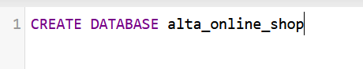

2. Create table users

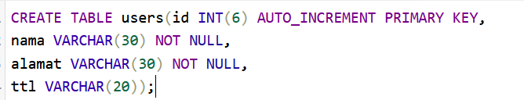

3. Create Table item_product

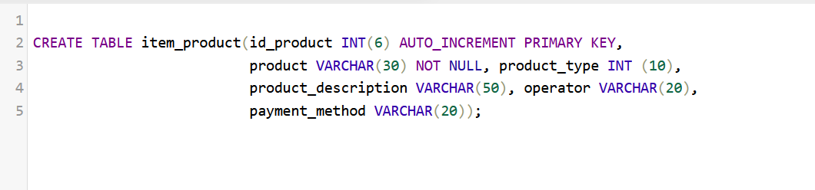

4. Create Table transaction

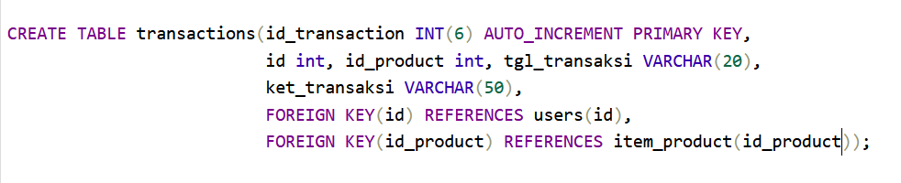

5. Create Table kurir

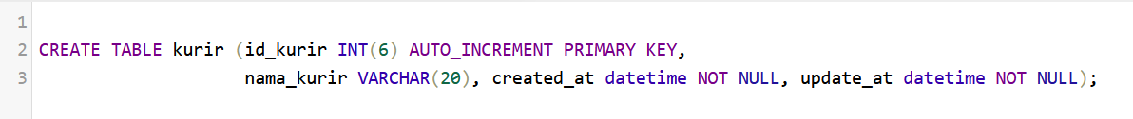

6. Adding column ongkos_dasar

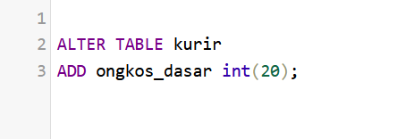

7. Rename column ongkos_dasar as shipping



8. Drop column shipping

